

**LAB REPORT – 3**

**Computer & Networks**

**M. Sumanth Reddy**

**1.Design a MAN network using single router and configure router with CLI mode**

**Intro:**

Designing a Metropolitan Area Network (MAN) with a single router typically involves connecting multiple local networks within a city or a larger geographical area to provide communication and data sharing capabilities. To design a simple MAN network using a single router, you'll need to outline the network topology and then configure the router using the Command Line Interface (CLI).

**Establishing the connection:**

To arrange the connections in MAN network we have some number of Pc’s and two Switches and Router and them each other. After that we have to assign the IP address to each of the Pc’s and we divide the two switches as Network A and Network B and we have leave one IP address in each Network and that IP address should be enter into **Default Gateway** of each Pc. After that same IP address should be entered into the Ethernet0/0 and Ethernet0/1 position in the Router

Note: The IP addresses of both Network A & B must not be in sequence or else it will raise an ERROR.

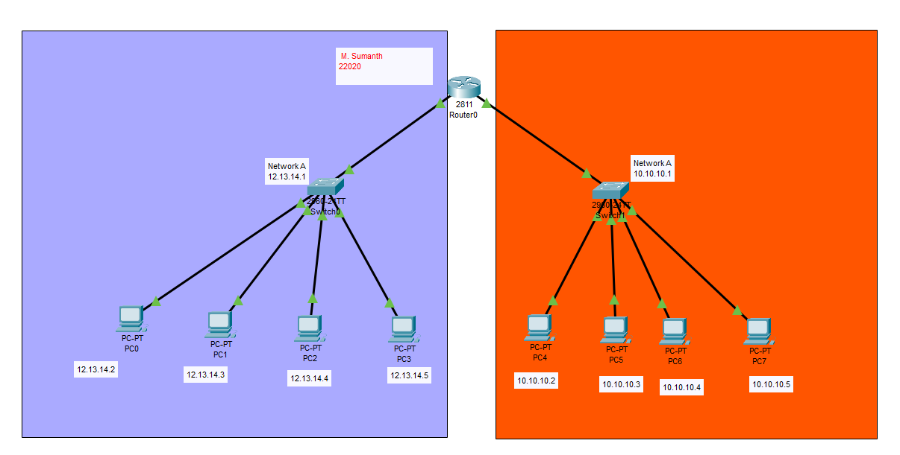

**Two Methods of Entering IP configuration & IPV4 address:**

A) By Entering Manually into each Ethernet and on the Port status

B) By Declaring the Values and On the Port status by using CLI mode

**A) By Entering Manually into each Ethernet and on the Port status:**

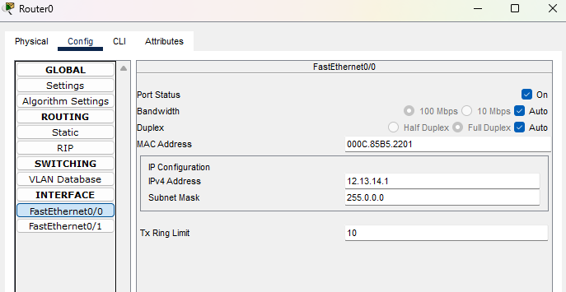

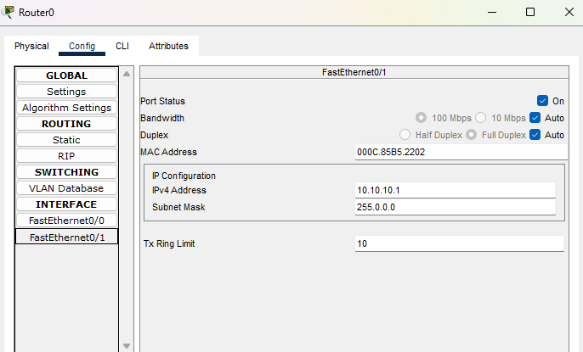

**B) By Declaring the Values and On the Port status by using CLI mode:**

The commands to be written in CLI to give an IP address and to ON the port status.

exit

>enable

#configure

#interface FastEthernet0/0

#ip address 1323.23.132 23.1313.13

(Ip configuration) (IPV4 address)

#no shutdown (or #no shut)

and it will assign the Ip and turn on the router ethernet

**Before:**

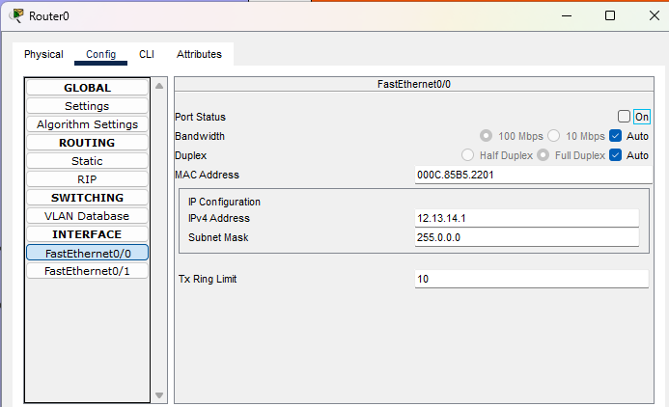

**After Switching values using CLI**

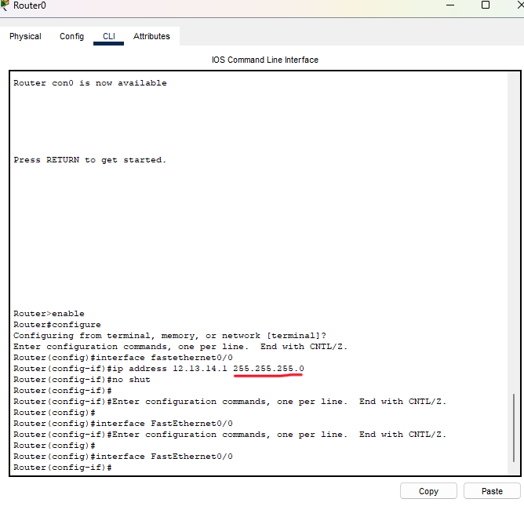

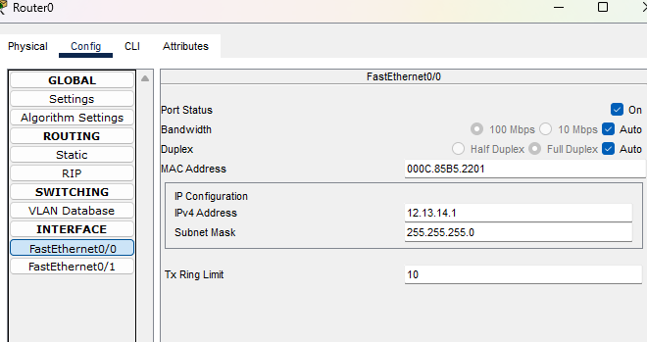

**Transferring Packets:**

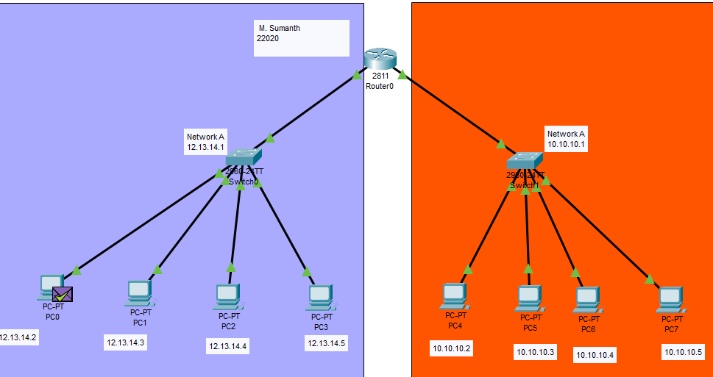

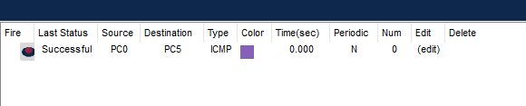

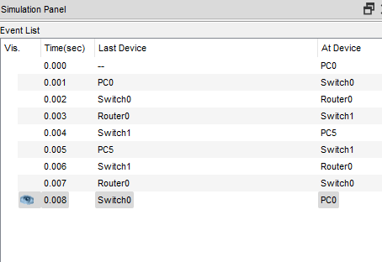

**Ping:**

By using Ping, we can check the connection from the one pc to another pc by using IP address and it display the time taken to connect and show no of packets have been transferred, received and lost while transferring.

In Some cases, due to some network issues the packets which was will be lost.

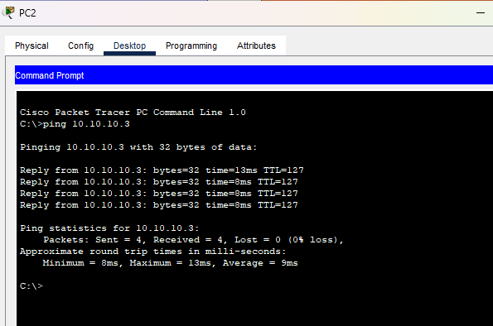

**Pros:**

**Centralized Control:** With a single router, you have centralized control over the entire MAN network. This makes it easier to implement policies, monitor traffic, and troubleshoot issues.

**Easier Configuration:** Configuring a single router through the CLI mode can be easier for network administrators who are familiar with the specific router's command syntax.

**Lower Latency:** In a MAN with a single router, there is minimal routing delay since all traffic is processed by a single device. This can lead to lower latency compared to more complex routing setups.

**Cons:**

**Single Point of Failure:** The biggest disadvantage of a single-router MAN is that it represents a single point of failure. If the router experiences hardware or software issues, the entire MAN could go offline.

**Limited Scalability:** A single-router MAN may not be suitable for large-scale networks or future expansion. Adding more devices or expanding the network beyond the router's capacity can be challenging.

**Performance Bottleneck:** In a high-traffic MAN, a single router might become a performance bottleneck, leading to network congestion and reduced performance.

**Observation:**

Using a single router to configure a MAN via CLI mode can be a viable option for small to medium-sized networks with limited scalability requirements. It offers simplicity and cost savings but comes with the risk of a single point of failure and scalability limitations

**2. Design a WAN using the three routers using static routing**

**Intro:**

Designing a Wide Area Network (WAN) using three routers with static routing involves configuring the routers to route traffic between different networks using predetermined static routes. In this example, I'll assume that you have three routers named Router A, Router B, and Router C, and you want to connect three different LANs (Local Area Networks) together.

**Establishing the connection:**

To establish the connection in WAN network with three routers using Static Routing is little complex.

Firstly, we must take the routers A, B, C and connect the Three Pc’s to each switch and connect the switch to router and as usual assign the IP address for each Pc.

To connect each router, we must select the router **1841** after that in routers we cannot connect more than 2 connections, so we use **WIC-1T** to place at slot and in the middle router which connects both the routers we will place 2 WIC-1T at both slots.

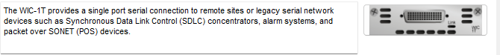

**Router A:**

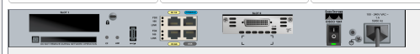

**Router B:**



**Router C:**



**Declaration of IP addresses:**

As we know, we have each IP address for each PC and the Default IP to be enter into each Pc Default Gateway and Default Gateway address also to be entered into the IPV4 address of Router in FastEthernet0/0 and we have to assign a random IP address to the Router of Serial0/0/0 and to the Router B which having two Serial Ports we will assign Two IP addresses. And we have to each Router using Thunder wire

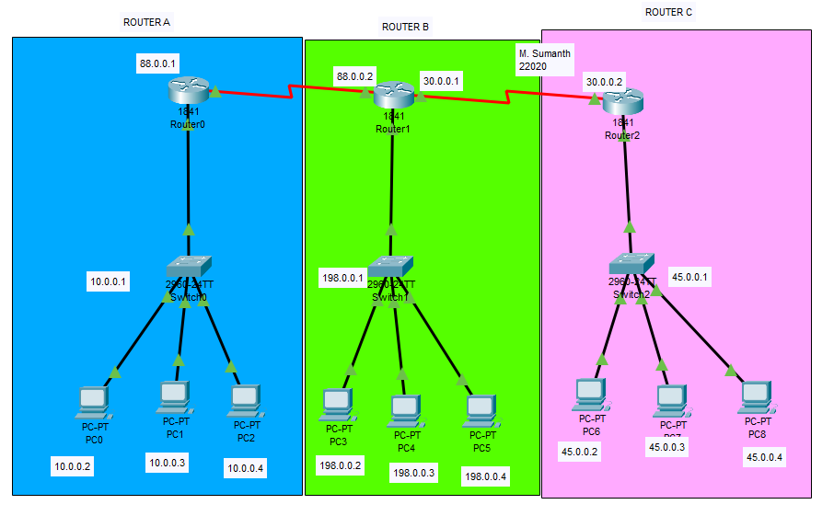

**Static Routing:**

In static routing we have to select the static option in router’s config mode after that we can have the options of Network, Mask, and Next Hop.

Suppose for the Router A we will assign

**Network: 198.0.0.0**

**Mask: 255.0.0.0**

**Next Hop: 88.0.02**

We had assigned 198.0.0.0 because we must connect every Pc, so we have written Default serial number and Next Hop as next IP address after Router A and we have to add above credinals.

In Router A and C, we must add 3 Static routings and for every static Next Hop will remain same.

But for the Router B it only contains 2 static routings as address of Router A and C and Next Hop also be different.

**Router A:**

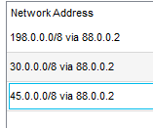

**Router B:**

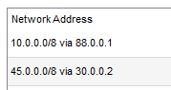

**Router C:**

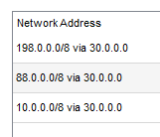

**Transferring Packets:**

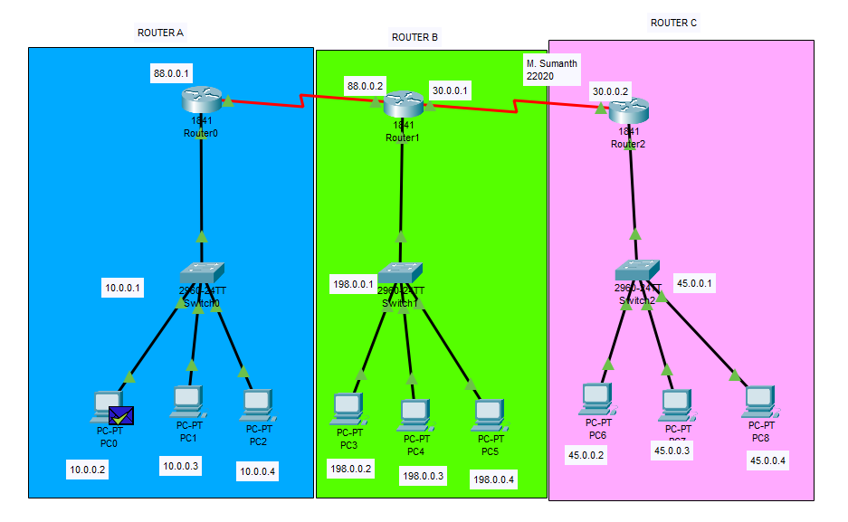

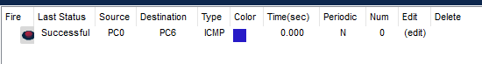

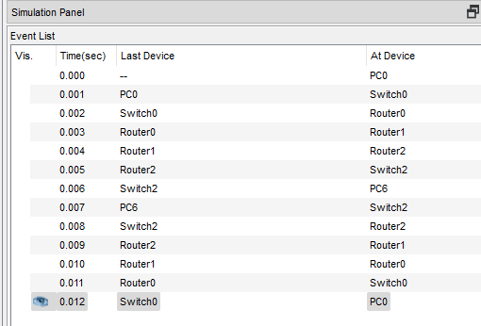

**Ping:**

By using Ping, we can check the connection from the one pc to another pc by using IP address and it display the time taken to connect and show no of packets have been transferred, received and lost while transferring.

In Some cases, due to some network issues the packets which was will be lost.

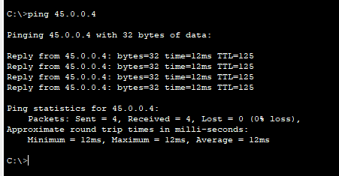

**Pros:**

**Predictable Routing:** With static routes, you have full control over the routing paths. You can explicitly define the route for each network, ensuring that traffic takes the desired path without unexpected changes due to dynamic routing updates.

**Security:** Static routes can enhance network security because they don't automatically adapt to changes in the network topology. This means that unauthorized or unexpected changes to the routing table are less likely.

**Cost-Efficiency:** Static routing can be cost-effective, as it doesn't require powerful routers or dedicated hardware for dynamic routing protocols.

**Cons:**

**Maintenance Overhead:** As the network grows, managing static routes can become a significant administrative burden. Keeping track of all routes and ensuring they are up to date can be challenging.

**Complex Routing Policies:** If you have complex routing policies, such as traffic engineering or policy-based routing, static routing may not be flexible enough to accommodate these requirements.

**Observation:**

Using three routers with static routing in a WAN has the advantage of simplicity and control but can become challenging to manage as the network scales and may not adapt well to dynamic changes.